29 - Beatles – Saw Her Standing
Original: E Us: D WURLI Greg is only solo
[Intro] D | D | D | D

[Verse/Chorus]
D7 | D7 | G7 | D7
D7 | D7 | A7 | A7
D | D7/F# | G | Bb
D | A7 | D | D (last chord: am over D)

[Bridge]
G | G | G | G
G | G | A7 | A7 | G7 | G7
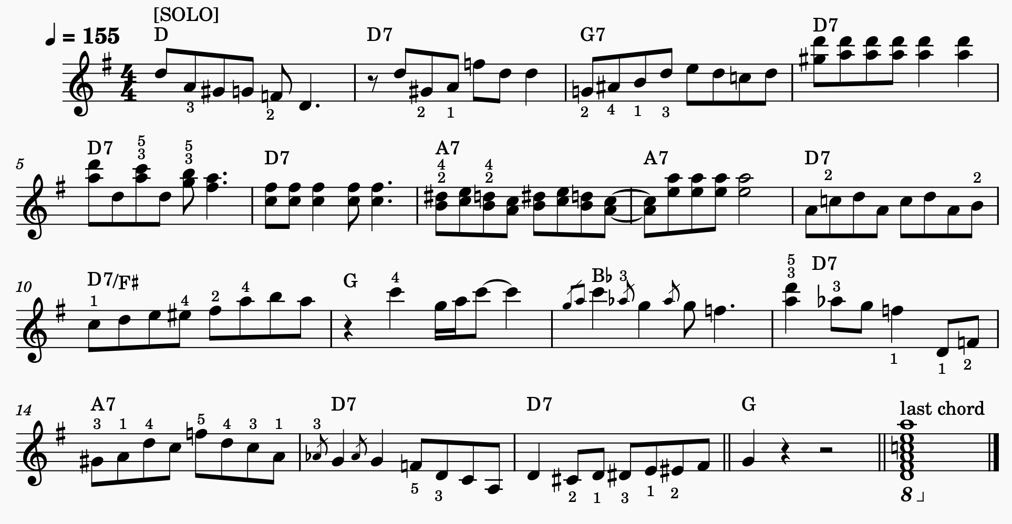
[Solos]

